Supplementary Material

Supplementary Tables
Supplementary Table S1. Per-exposure Mendelian-randomisation instruments. Instrument count, F-statistics, and inverse-variance-weighted estimates for each microbial exposure.
Exposure | p_threshold | nSNP_prclump | nSNP_used | mean_F | min_F | IVW_OR | IVW_CI | IVW_p | PRESSO_global_p
H. pylori IgG seropositivity | 5e-8 -> 1e-5 (locus-wide) | 21 | 17 | 21.6 | 19.7 | 0.96 | 0.71-1.30 | 0.79 | 0.052
Streptococcus (genus) | 5e-8 -> 1e-5 (locus-wide) | 17 | 15 | 22.5 | 19.3 | 1.1 | 0.90-1.34 | 0.35 | 0.159
Fusobacterium | 5e-8 -> 1e-5 (locus-wide) | 25 | 23 | 22.8 | 19.6 | 1.04 | 0.79-1.36 | 0.79 | 0.611
Prevotella | 5e-8 -> 1e-5 (locus-wide) | 19 | 15 | 20.9 | 19.4 | 0.98 | 0.84-1.14 | 0.76 | 0.605
Veillonella | 5e-8 -> 1e-5 (locus-wide) | 11 | 8 | 21.2 | 19.9 | 1.04 | 0.84-1.29 | 0.69 | 0.676
Lactobacillus | 5e-8 -> 1e-5 (locus-wide) | 12 | 10 | 22.1 | 20.3 | 0.96 | 0.84-1.09 | 0.51 | 0.542
Supplementary Table S2. MR-PRESSO global tests. Horizontal-pleiotropy global test per exposure.
exposure | RSSobs | PRESSO_global_p
H. pylori IgG seropositivity | 32.6 | 0.052
Streptococcus (genus) | 23.1 | 0.159
Lactobacillus | 10.3 | 0.542
Prevotella | 14 | 0.605
Fusobacterium | 21.8 | 0.611
Veillonella | 6.39 | 0.676
Supplementary Table S3. TRIPOD checklist. Item-by-item reporting location (provided as separate TRIPOD_checklist file).
Supplementary Table S4. Alpha-diversity effect sizes. Cliff’s delta and Wilcoxon p for Observed/Shannon/Simpson across the disease cascade.
metric | median_Nonul | median_GCN | cliffs_delta | wilcox_p
Observed | 47 | 30 | -0.27 | 3.3e-07
Shannon | 2.18 | 1.92 | -0.122 | 0.0211
Simpson | 0.781 | 0.756 | -0.072 | 0.172
Supplementary Table S5. Non-circular single-cell localisation. Dominant cell type per stromal hub gene, excluding cluster-annotation markers.
gene | dominant_cell_type | frac_in_dominant | panel
ANTXR1 | Fibroblast | 0.863 | stromal_hub
COL6A3 | Fibroblast | 0.977 | stromal_hub
SPARC | Fibroblast | 0.653 | stromal_hub
POSTN | Fibroblast | 0.973 | stromal_hub
MXRA8 | Fibroblast | 0.98 | stromal_hub
FN1 | Fibroblast | 0.914 | stromal_hub
COL8A1 | Fibroblast | 0.998 | stromal_hub
VCAN | Fibroblast | 0.972 | stromal_hub
GFPT2 | Fibroblast | 0.527 | stromal_hub
THBS2 | Fibroblast | 0.82 | stromal_hub
AEBP1 | Fibroblast | 0.924 | stromal_hub
BGN | Fibroblast | 0.972 | stromal_hub
SULF1 | Fibroblast | 0.773 | stromal_hub
COL5A1 | Fibroblast | 0.937 | stromal_hub
BICC1 | Fibroblast | 0.97 | stromal_hub
FBN1 | Fibroblast | 0.932 | stromal_hub
ISLR | Fibroblast | 0.902 | stromal_hub
CDH11 | Fibroblast | 0.96 | stromal_hub
SFRP4 | Fibroblast | 0.987 | stromal_hub
SCARF2 | Fibroblast | 0.736 | stromal_hub
PRRX1 | Fibroblast | 0.979 | stromal_hub
FNDC1 | Fibroblast | 0.983 | stromal_hub
ITGA11 | Fibroblast | 0.984 | stromal_hub
Supplementary Table S6. GSE84437 pT-stage-stratified validation. Signature discrimination within pT-stage strata.
subset | n | events | C | C_se | HR_perSD | CI | p | C_below_0.5
All (T1-T4) | 431 | 207 | 0.465 | 0.021 | 1.14 | 1.00-1.29 | 0.0512 | True
Early (T1-T3) | 141 | 47 | 0.444 | 0.046 | 1.21 | 0.96-1.54 | 0.108 | True
Late (T4) | 290 | 160 | 0.483 | 0.024 | 1.09 | 0.93-1.27 | 0.29 | True
T2-T3 only | 130 | 45 | 0.442 | 0.047 | 1.23 | 0.96-1.56 | 0.0978 | True
Supplementary Table S7. Data-acquisition & reproducibility checklist. Accessions, tools, versions, script-to-result mapping (see manuscript Appendix and PIPELINE file).

Supplementary Figures
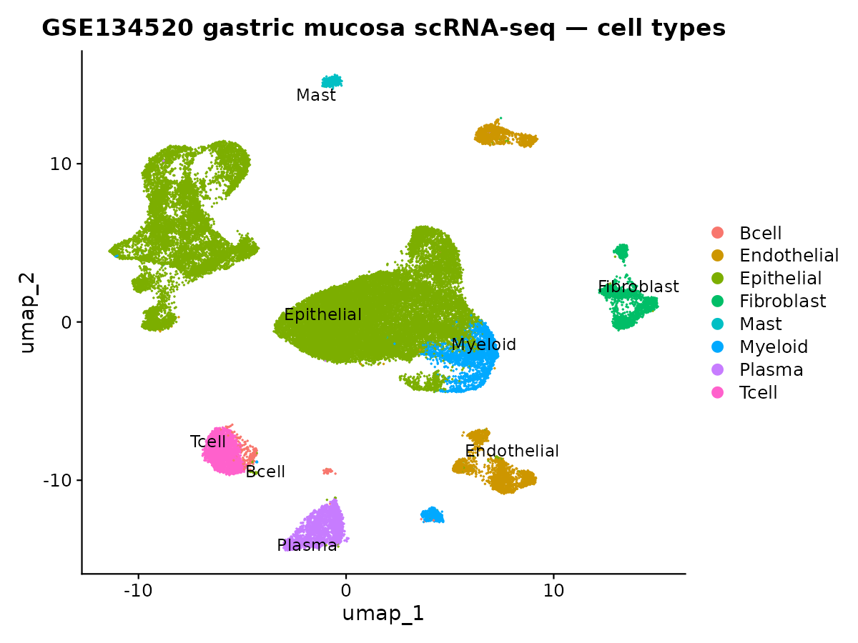
Supplementary Figure S1
Supplementary Figure S1. Single-cell atlas (GSE134520). UMAP of 43,992 cells from the premalignant-to-early-gastric-cancer cascade, coloured by the eight annotated major cell types (Epithelial 68.6%, Endothelial 7.6%, Myeloid 6.4%, Plasma 5.8%, T-cell 5.8%, Fibroblast 4.2%, Mast 1.0%, B-cell 0.6%). Provides the cellular reference underlying the module-localisation analysis (Figure 3C, §3.10). File: results/scrna/UMAP_celltypes.png.
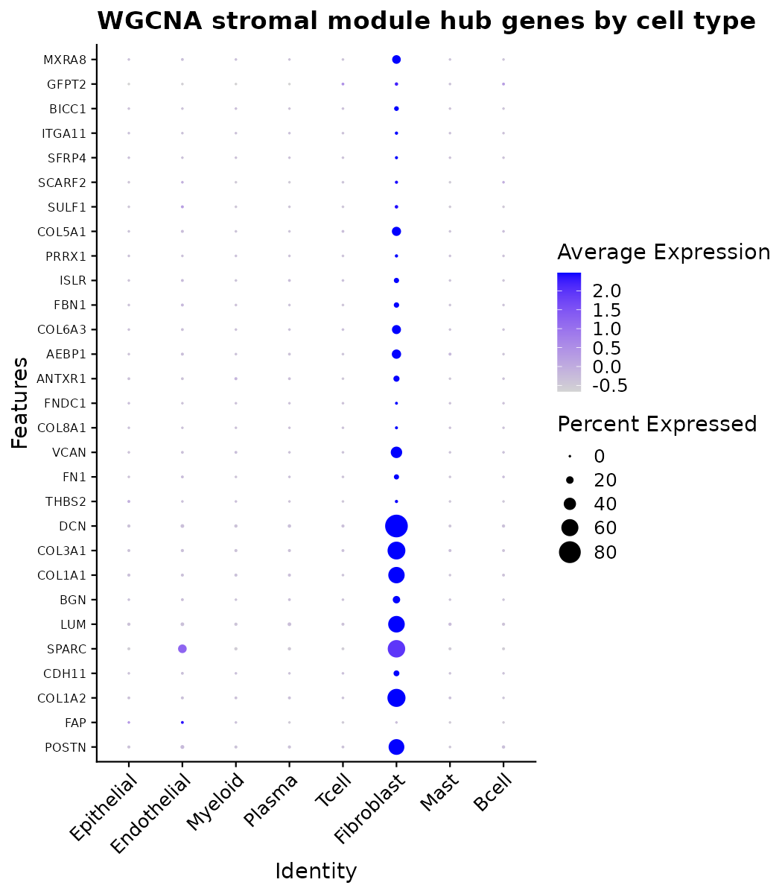
Supplementary Figure S2
Supplementary Figure S2. Stromal hub-gene expression by cell type. Dot plot of prognostic WGCNA red-module hub genes across the eight cell types (dot size = fraction of cells expressing; colour = scaled mean expression). Hub-gene expression is confined to the fibroblast compartment, providing the direct visual basis for the non-circular localisation result (all 23/23 non-annotation hub genes fibroblast-dominant; §3.10, Supplementary Table S5). File: results/scrna/DotPlot_stromal_module_hub.png.
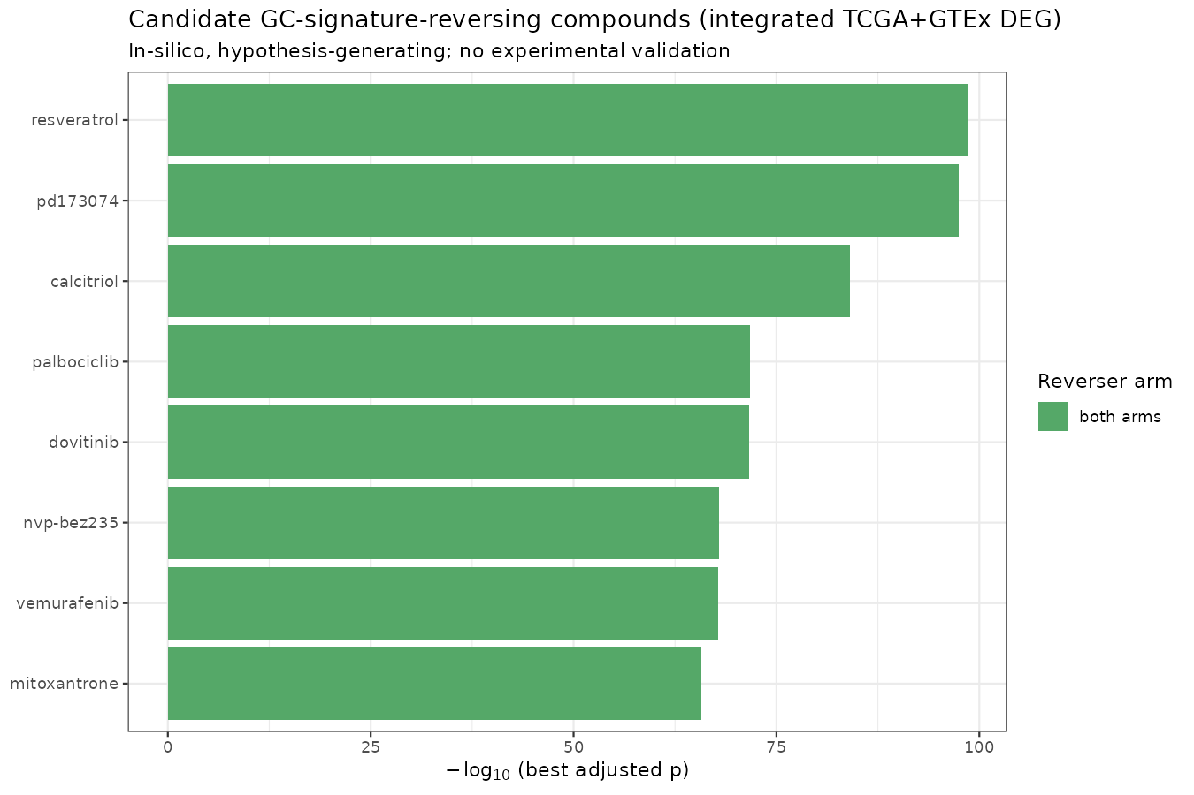
Supplementary Figure S3
Supplementary Figure S3. In-silico drug-repurposing candidates. Top compounds whose transcriptional perturbation signature reverses the tumour-up/tumour-down programme on both arms (Enrichr against LINCS L1000 and GEO drug-perturbation libraries), ranked by combined score. Nominated classes are dominated by PI3K/mTOR (NVP-BEZ235), CDK4/6 (palbociclib) and FGFR/multikinase (PD-173074, dovitinib) inhibitors — anti-proliferative agents concordant with the proliferation-dominated signature. Hypothesis-generating only; no experimental validation (§3.11). File: results/drug_repurposing_integrated/top_candidate_drugs.png.
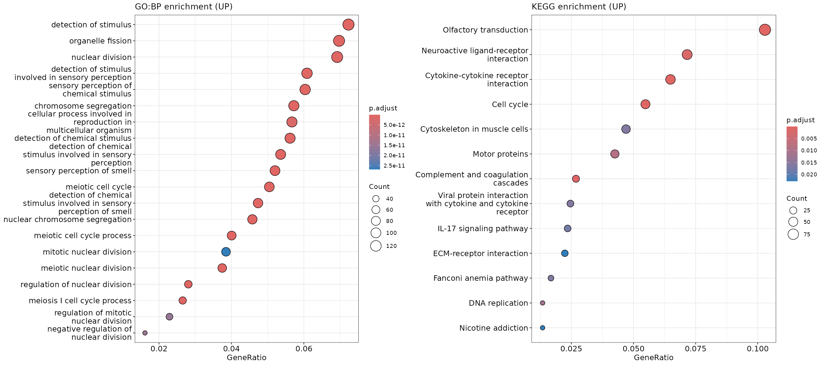
Supplementary Figure S4
Supplementary Figure S4. Over-representation analysis (GO:BP and KEGG, tumour-up genes). clusterProfiler ORA dot plots for the tumour-up gene set (dot size = gene count; colour = adjusted p). Cell-cycle/nuclear-division and ECM-receptor/cytokine terms dominate, concordant with the proliferation and stromal programmes. Note that ORA depends on the significance threshold and is sensitive to gene-family size — the prominent “olfactory/sensory-perception” terms reflect the large olfactory-receptor family rather than tumour biology; the threshold-free GSEA in Figure 1 is therefore the primary enrichment method, with ORA shown for completeness (§3.2). Files: results/enrichment/dotplot_GO_BP_UP.png, results/enrichment/dotplot_KEGG_UP.png.
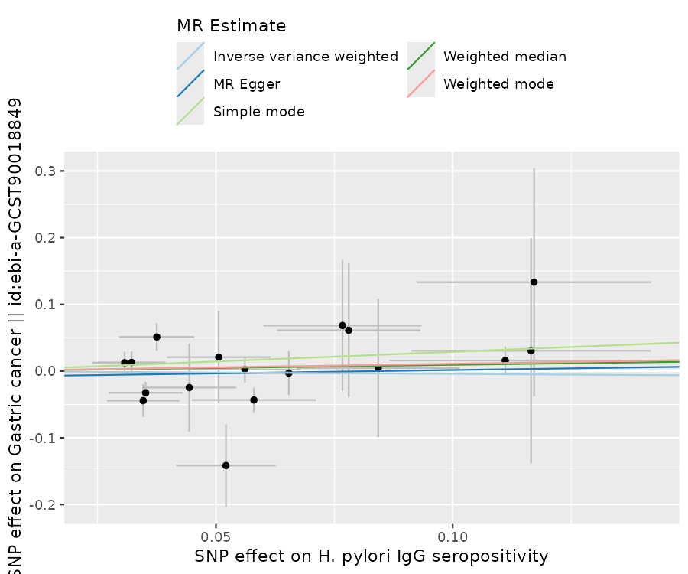
Supplementary Figure S5
Supplementary Figure S5. Mendelian-randomisation scatter (representative exposure). SNP-exposure vs SNP-outcome effects for anti-H. pylori IgG seropositivity on gastric cancer, with the five MR method slopes overlaid (IVW, MR-Egger, weighted median, weighted mode, simple mode). All slopes are flat and indistinguishable from zero (IVW OR 0.96, 0.71–1.30; §3.9). Analogous plots for all six exposures in both ancestries are in results/mr_real/ and results/mr_real_eas/. File: results/mr_real/scatter_H__pylori_IgG_seropositivity.png.
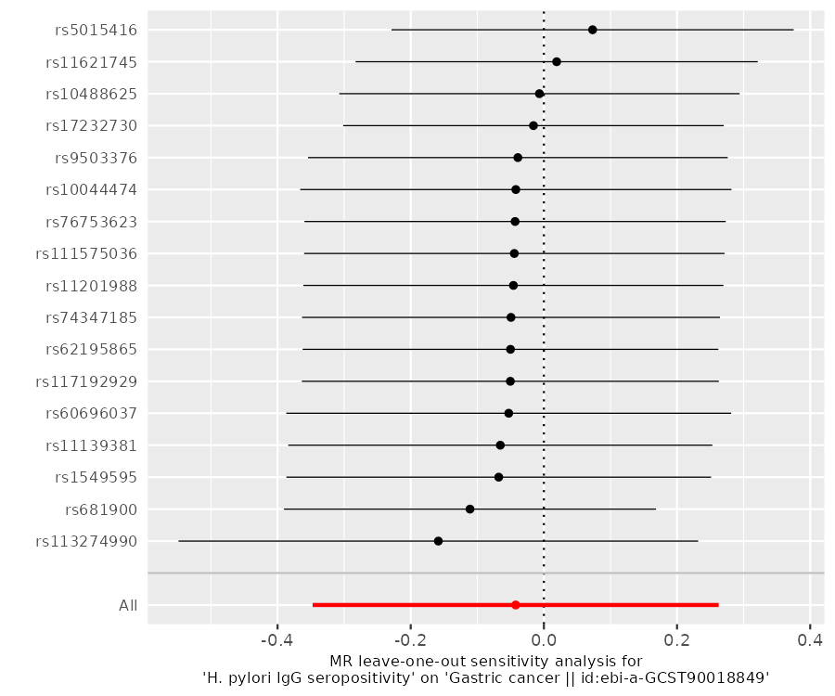
Supplementary Figure S6
Supplementary Figure S6. Mendelian-randomisation leave-one-out (representative exposure). Leave-one-out IVW estimates for anti-H. pylori IgG seropositivity: removing any single SNP leaves the pooled estimate straddling the null, confirming no individual instrument drives the result (§3.9). File: results/mr_real/loo_H__pylori_IgG_seropositivity.png.
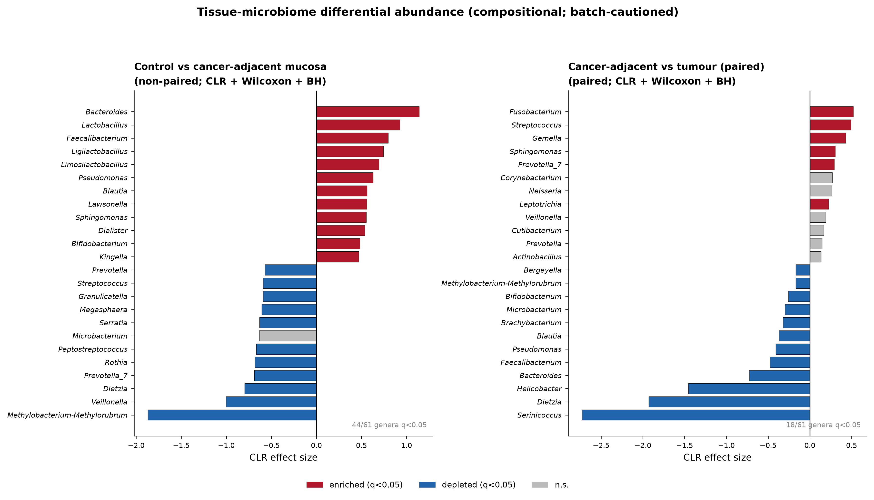
Supplementary Figure S7
Supplementary Figure S7. Tissue-microbiome compositional differential abundance. Centred-log-ratio (CLR) effect sizes for the two discovery-cohort contrasts (Wilcoxon, Benjamini–Hochberg): (left) control vs cancer-adjacent mucosa (44/61 genera q<0.05) and (right) paired cancer-adjacent vs tumour (18/61 genera q<0.05). Bars coloured by direction where q<0.05 (red enriched, blue depleted, grey n.s.); the twelve most enriched and depleted genera are shown per panel. These genus-level shifts are reported for completeness but, as detailed in §3.8, are confounded with sequencing batch in the tumour contrast and do not replicate in the independent batch-clean cohort, so they are not proposed as biomarkers. Files: results/microbiome_biomarker/04a_DA_control_vs_GCN.csv, 04b_DA_GCN_vs_GCT_paired.csv.
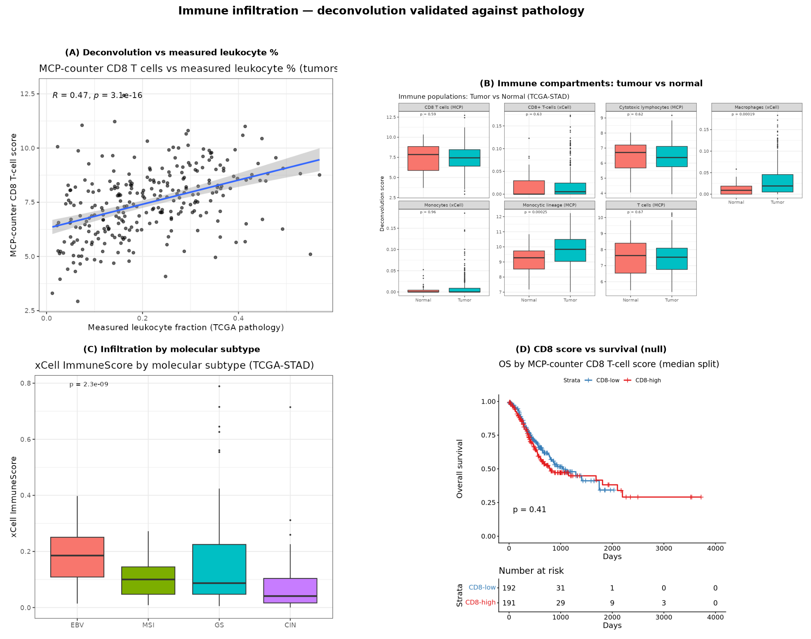
Supplementary Figure S8
Supplementary Figure S8. Immune infiltration, deconvolution validated against pathology. (A) Deconvolution T-cell score versus the measured histological leukocyte fraction (Spearman ρ=0.67, p=3.6×10⁻³⁶), establishing that the expression-based estimates track true tissue composition. (B) Immune compartments, tumour versus normal — enrichment is dominated by the macrophage/monocyte lineage, with no net CD8⁺ gain. (C) Infiltration by molecular subtype (EBV/MSI most infiltrated, Kruskal–Wallis p<10⁻⁶). (D) CD8⁺ score versus overall survival — not prognostic in this cohort (Cox HR 1.04, p=0.41), reported as observed (§3.3). Files: results/plots/Immune_*.png.
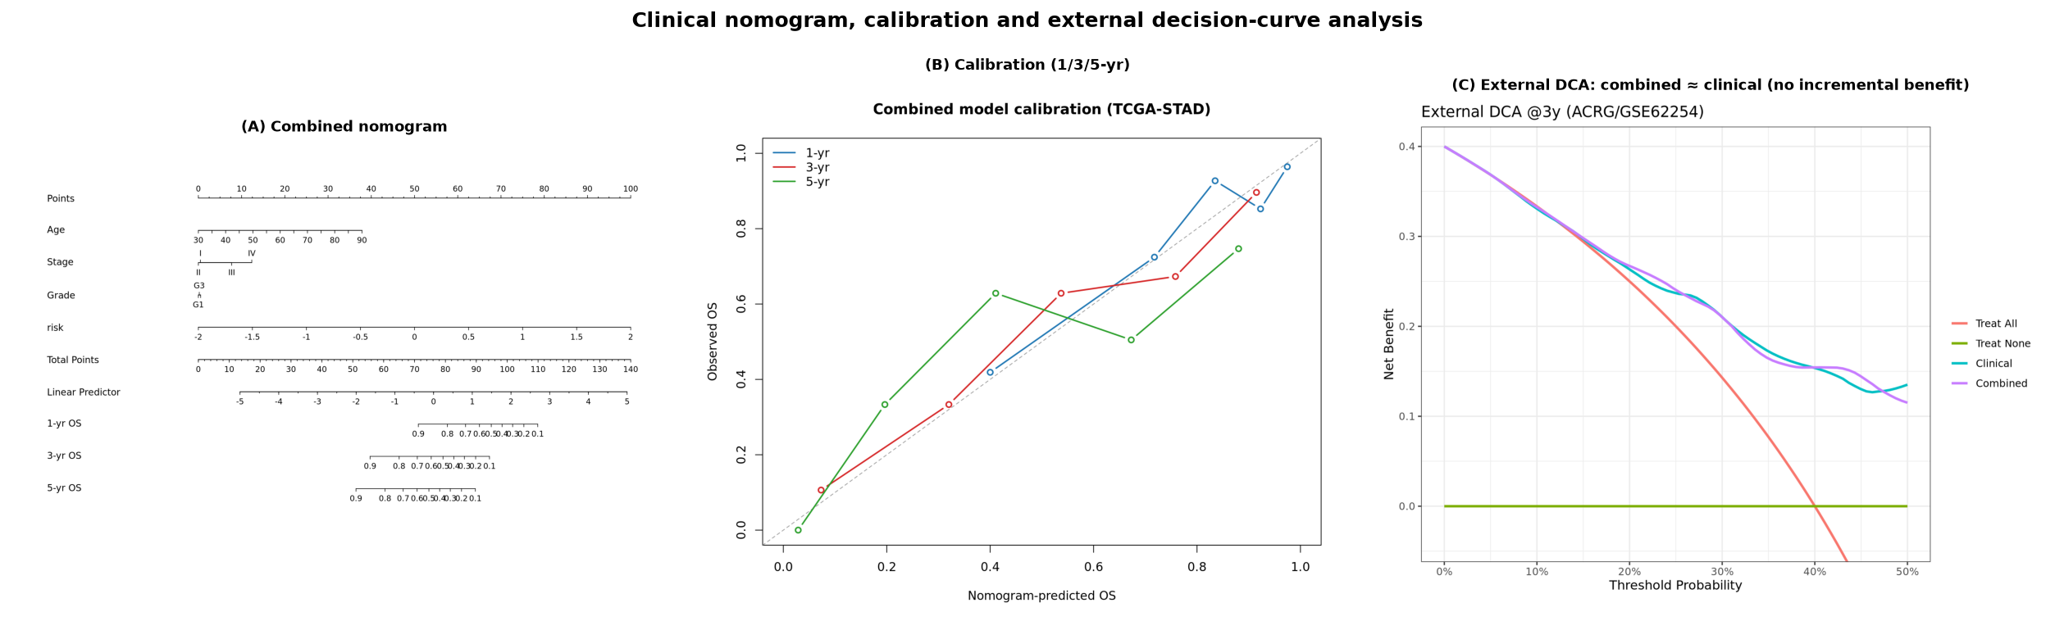
Supplementary Figure S9
Supplementary Figure S9. Clinical nomogram, calibration and external decision-curve analysis. (A) Combined clinical+signature nomogram for 1/3/5-year overall survival. (B) Calibration at 1/3/5 years (in-sample). (C) External decision-curve analysis in ACRG: both the clinical and the combined models carry net benefit over treat-all/treat-none, but their curves are essentially superimposed across the 5–40% threshold range, i.e. adding the signature confers no incremental net benefit over standard staging out-of-sample (§3.7). The nomogram is presented as an illustrative research tool, not a validated decision instrument. Files: results/nomogram_combined/, results/external_utility_ACRG/DCA_external.png.
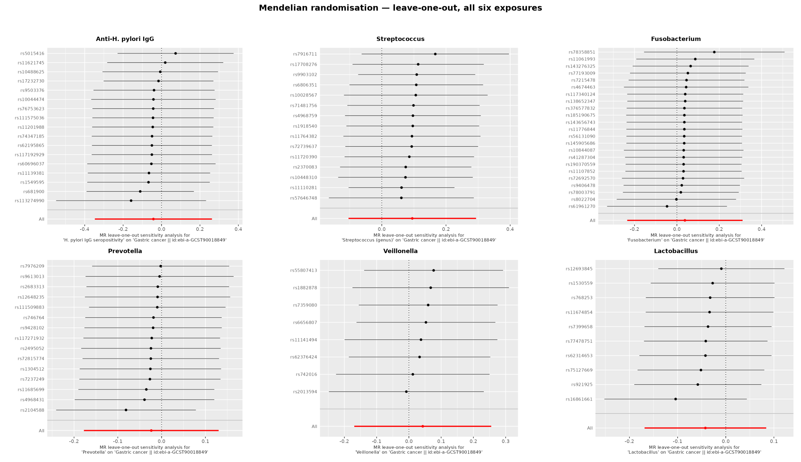
Supplementary Figure S10
Supplementary Figure S10. Mendelian-randomisation leave-one-out — all six exposures. Leave-one-out IVW estimates for each exposure: removing any single SNP leaves every pooled estimate straddling the null, confirming that no individual instrument drives any result and that the null is not an outlier artefact (§3.9). Files: results/mr_real/loo_*.png.
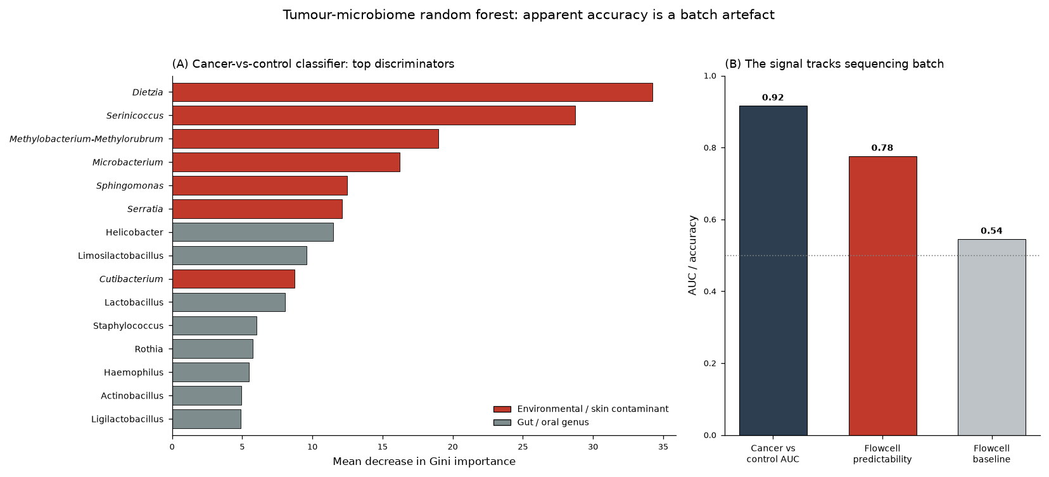
Supplementary Figure S11
Supplementary Figure S11. The tumour-microbiome classifier is a batch artefact. (A) Top fifteen genera ranked by mean decrease in Gini importance in the cancer-versus-control random forest; genera in red italic are environmental or skin contaminants (Dietzia, Serinicoccus, Methylobacterium–Methylorubrum, Microbacterium, Sphingomonas, Serratia), not gut or oral commensals, and dominate the classifier. (B) The classifier’s apparent discrimination (cancer-versus-control AUC 0.92, 95% CI 0.90–0.94) is not biological: the same feature space predicts the sequencing flowcell among biologically-similar samples at 78% accuracy versus a 55% majority baseline (dotted line = chance). The apparent tumour signal therefore tracks sequencing batch rather than tumour biology (§3.8). Files: results/microbiome_biomarker/05_rf_importance.csv, 05_rf_metrics_and_batch_sanity.csv.

